[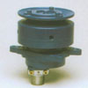](http://www.bgsha.com/ru/learning/images/traktora/kartinki%20traktorov/2.jpg)

[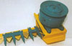](http://www.bgsha.com/ru/learning/images/traktora/kartinki%20traktorov/3.jpg)

[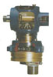](http://www.bgsha.com/ru/learning/images/traktora/kartinki%20traktorov/10.jpg)