20-40马力东风牌拖拉机价格表（非洲、亚洲、东欧、南美洲、前苏联等地区适用机型） 2010-9-13
No | Model | Description of Production | 产品描述 | G.W./  N.W.  （KG） | 铁架包装
1 | DF-200  (20HP) | DONGFENG Brand Four-wheel Tractor 2WD, fitted with 3-cylinder diesel engine of 20 hp, with metal sheet hood, single-function clutch, independent meters, mechanical steering, high quality seat system, twin turning speeds of PTO:540 /730prm, gear box: (4+1)×2, tyre 8.30-24-24/4.00-16. | DF-200拖拉机，2轮驱动，20马力三缸柴油机，金属机罩，单作用离合器，独立式仪表，机械转向，高质量座椅，双速PTO：540/730rpm, 变速箱：(4+1)×2，轮胎：8.30-24/4.00-16。 | 1420/  1220 | 228×145×110cm  16 台/ 40’柜  12台带驾驶室 / 40’高柜
2 | DF-204  (20HP) | DONGFENG Brand Four-wheel Tractor 4WD, fitted with 3-cylinder diesel engine of 20 hp, with metal sheet hood, single-function clutch, independent meters, mechanical steering, high quality seat system, twin turning speeds of PTO:540 /730prm, gear box: (4+1)×2, tyre 8.30-24/6.00-12. | DF-204拖拉机，4轮驱动，20马力三缸柴油机，金属机罩，单作用离合器，独立式仪表，机械转向，高质量座椅，双速PTO：540/730rpm,变速箱：(4+1)×2，轮胎：8.30-24/6.00-12。 | 1570/  1370 | 228×145×110cm  16 台/ 40’柜  12台带驾驶室 / 40’高柜
3 | DF-240  (25HP) | DONGFENG Brand Four-wheel Tractor 2WD, fitted with 3-cylinder diesel engine of 24 hp, with metal sheet hood, single-function clutch, independent meters, mechanical steering, high quality seat system, twin turning speeds of PTO:540 /730prm, gear box: (4+1)×2, tyre 9.50-24/5.00-15. | DF-240拖拉机，2轮驱动，24马力三缸柴油机，金属机罩，单作用离合器，独立式仪表，机械转向，高质量座椅，双速PTO：540/730rpm,变速箱：(4+1)×2，轮胎9.50-24/5.00-15。 | 1420/  1220 | 228×145×110cm  16 台/ 40’柜  12台带驾驶室 / 40’高柜
4 | DF-244  (25HP) | DONGFENG Brand Four-wheel Tractor 4WD, fitted with 3-cylinder diesel engine of 24 hp, with metal sheet hood, single-function clutch, independent meters, mechanical steering, high quality seat system, twin turning speeds of PTO:540 /730prm, gear box: (4+1)×2, tyre 9.50-24/6.00-12. | DF-244拖拉机，4轮驱动，24马力三缸柴油机，金属机罩，单作用离合器，独立式仪表，机械转向，高质量座椅，双速PTO：540/730rpm,变速箱：(4+1)×2，轮胎：9.50-24/6.00-12。 | 1570/  1370 | 228×145×110cm  16 台/ 40’柜  12台带驾驶室 / 40’高柜
5 | DF-300A  (30HP simple model) | DONGFENG Brand Four-wheel Tractor 2WD, fitted with 3-cylinder diesel engine of 30hp, with streamline metal sheet hood, single-function clutch, independent meters, mechanical steering, high quality seat system, twin turning speeds of PTO:540 /730prm, gear box: (4+1)×2, tyre 9.50-24/5.00-15. | DF-300A拖拉机，2轮驱动，30马力三缸柴油机，金属机罩，单作用离合器，独立式仪表，机械转向，高质量座椅，双速PTO：540/730rpm,变速箱：(4+1)×2，轮胎9.50-24/5.00-15。 | 1470/  1270 | 228×145×125cm  16 台/ 40’柜
6 | DF-304A  (30HP simple model) | DONGFENG Brand Four-wheel Tractor 4WD, fitted with 3-cylinder diesel engine of 30hp, with streamline metal sheet hood, single-function clutch, independent meters, mechanical steering, high quality seat system, twin turning speeds of PTO:540 /730prm, gear box: (4+1)×2, tyre 9.50-24/6.00-16. | DF-304A拖拉机，4轮驱动，30马力三缸柴油机，金属机罩，单作用离合器，独立式仪表，机械转向，高质量座椅，双速PTO：540/730rpm,变速箱：(4+1)×2，轮胎：9.50-24/6.00-16。 | 1620/  1420 | 228×145×125cm  16 台/ 40’柜
7 | DF-300  (30HP) | DONGFENG Brand Four-wheel Tractor 2WD, fitted with 3-cylinder diesel engine of 30hp, with streamline metal sheet hood, dual-function clutch, independent meters, mechanical steering, high quality seat system, twin turning speeds of PTO:540 /1000prm, gear box: (4+1)×2, tyre 11.2-24/5.00-15. | DF-300拖拉机，2轮驱动，30马力三缸柴油机，金属机罩，双作用离合器，独立式仪表，机械转向，高质量座椅，双速PTO：540/1000rpm,变速箱：(4+1)×2，轮胎11.2-24/5.00-15。 | 1760/  1560 | 228×145×125cm  16 台/ 40’柜
8 | DF-304  (30HP) | DONGFENG Brand Four-wheel Tractor 4WD, fitted with 3-cylinder diesel engine of 30hp, with streamline metal sheet hood, dual-function clutch, independent meters, power steering, high quality seat system, twin turning speeds of PTO:540 /1000prm, gear box: (4+1)×2, tyre 11.2-24/6.50-16. | DF-304拖拉机，4轮驱动，30马力三缸柴油机，金属机罩，双作用离合器，独立式仪表，液压转向，高质量座椅，双速PTO：540/1000rpm,变速箱：(4+1)×2，轮胎：11.2-24/6.50-16。 | 1910/  1710 | 228×145×125cm  16 台/ 40’柜  12台带驾驶室 / 40’高柜
9 | DF-350  (35HP) | DONGFENG Brand Four-wheel Tractor 2WD, fitted with 3-cylinder diesel engine of 35hp, with streamline metal sheet hood, dual-function clutch, independent meters, mechanical steering, high quality seat system, twin turning speeds of PTO:540 /1000prm, gear box: (4+1)×2, tyre 11.2-24/5.00-15. | DF-350拖拉机，2轮驱动，35马力三缸柴油机，金属机罩，双作用离合器，独立式仪表，机械转向，高质量座椅，双速PTO：540/1000rpm,变速箱：(4+1)×2，轮胎11.2-24/5.00-15。 | 1810/  1610 | 228×145×125cm  16 台/ 40’柜
10 | DF-354  (35HP) | DONGFENG Brand Four-wheel Tractor 4WD, fitted with 3-cylinder diesel engine of 35hp, with streamline metal sheet hood, dual-function clutch, independent meters, power steering, high quality seat system, twin turning speeds of PTO:540 /1000prm, gear box: (4+1)×2, tyre 11.2-24/6.50-16. | DF-354拖拉机，4轮驱动，35马力三缸柴油机，金属机罩，双作用离合器，独立式仪表，液压转向，高质量座椅，双速PTO：540/1000rpm,变速箱：(4+1)×2，轮胎：11.2-24/6.50-16。 | 1960/  1760 | 228×145×125cm  16 台/ 40’柜  12台带驾驶室 / 40’高柜
11 | DF-400  (40HP) | DONGFENG Brand Four-wheel Tractor 2WD, fitted with 4-cylinder diesel engine of 40hp, with streamline metal sheet hood, dual-function clutch, independent meters, mechanical steering, high quality seat system, twin turning speeds of PTO:540 /1000prm, gear box: (4+1)×2, tyre 12.4-24/5.00-15. | DF-400拖拉机，2轮驱动，40马力四缸柴油机，金属机罩，双作用离合器，独立式仪表，机械转向，高质量座椅，双速PTO：540/1000rpm,变速箱：(4+1)×2，轮胎12.4-24/5.00-15。 | 1890/  1690 | 228×145×125cm  16 台/ 40’柜
12 | DF-404  (40HP) | DONGFENG Brand Four-wheel Tractor 4WD, fitted with 4-cylinder diesel engine of 40hp, with streamline metal sheet hood, dual-function clutch, independent meters, power steering, high quality seat system, twin turning speeds of PTO:540 /1000prm, gear box: (4+1)×2, tyre 12.4-24/7.50-16。 | DF-404拖拉机，4轮驱动，40马力四缸柴油机，金属机罩，单作用离合器，独立式仪表，液压转向，高质量座椅，双速PTO：540/1000rpm,变速箱：(4+1)×2，轮胎：12.4-24/7.50-16。 | 2040/  1840 | 228×145×125cm  16 台/ 40’柜  12台带驾驶室 / 40’高柜
13 |  | Rear ballast for 20-25 hp | 后配重 for 20-25 hp 拖拉机 |  | 选装件
13 |  | Rear ballast for 30-40 hp | 后配重 for 30-40 hp 拖拉机 |  | 选装件
13 |  | Air brake system for 20/25 hp | 气泵刹车系统for 20/25 hp 拖拉机 |  | 选装件
13 |  | Air brake system for 30/35/40 hp | 气泵刹车系统for 30/35/40 hp 拖拉机 |  | 选装件
13 |  | Folding ROPS | 防翻架 |  | 选装件
13 |  | Sun shade | 遮阳棚 |  | 选装件
13 |  | Hydraulic outlet( including valve) | 双路液压输出（含多路阀） |  | 选装件
13 |  | Cab with heater for DF-254/304/354/404 tractor | 暖风驾驶室 for DF-254/304/354/404拖拉机 |  | 选装件
13 |  | Hydraulic steering system for 20/25hp tractor | 液压转向系统 for 20/25hp tractor |  | 选装件
 |  | 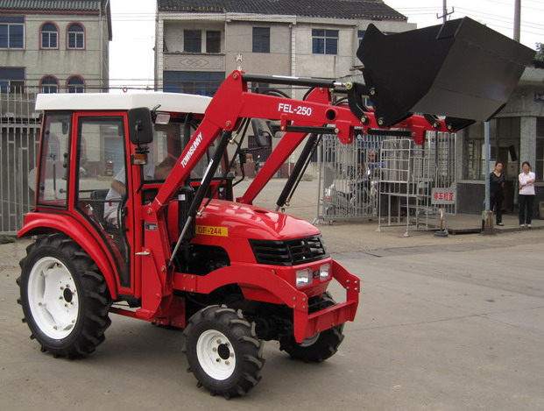 | 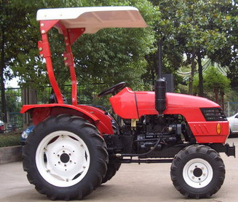 | 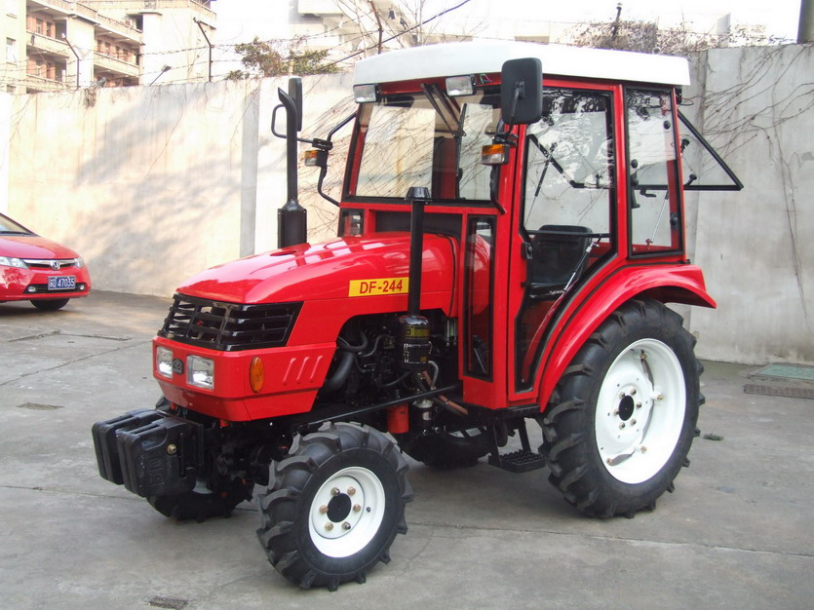

备注:
- DF-200/204/240/244 可以配套驾驶室 Можно с кабинна
- DF-200/204/240/244 可以选配液压转向系统；можно выбирать гидравлическая система рулевого управление
- DF-304/354/404 可以配套驾驶室；Можно с кабинна

